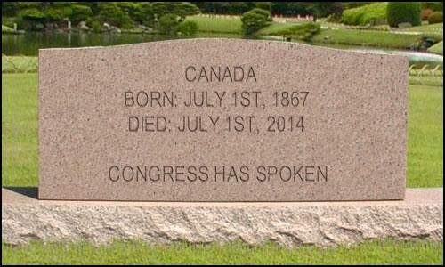

SEEKING US PERSONS IN CANADA - you need to learn about FATCA!!!
Are you a US citizen living in Canada? One of your parents born in the US?
Are you US/Canadian dual? Maybe an Accidental American?
Are you married to - - or a business partner of - - a "US Person"?
Are you a Snowbird who might be staying in the US too long?
Do you have a US Greencard that you no longer use but didn't legally renounce?
YOU NEED TO KNOW that FATCA (the US Foreign Account Tax Compliance Act) has been implemented worldwide and that our Canadian Government has signed an IGA (Intergovernmental agreement) making all financial institutions in Canada into investigative arms of the IRS!
YOU NEED TO KNOW that with the stroke of that pen YOU have become a 2nd CLASS CITIZEN in Canada in regard to financial privacy rights. And that very soon ALL YOUR FINANCIAL INFORMATION will be gathered up and forwarded to the IRS.
The Isaacbrocksociety.ca is making a strong continuing effort to inform individuals like yourself about their RIGHTS and OPTIONS, exploring what you and your family need to understand in relation to the complexity and breadth of these issues you now face.
Additionally, we are supporting efforts to raise awareness about the human rights failings & general social collateral damage issues surrounding Canada's FATCA IGA, which has resulted in this legalized 2nd class citizenship. A constitutional challenge has already been initiated within the Canadian courts.
Please join us to learn more and for ongoing lively and informative discussions.
http://www.isaacbrocksociety.ca also: http://www.adcs-adsc.ca/

